**University of Michigan – Dearborn**

**CIS 200 – Computer Science 2**

**Lab# 3**

Quan Le

[lmmquan@umich.edu](mailto:lmmquan@umich.edu)

October 7, 2024

**Table Content**

Contents

Question 1 3

Source Code 3

Description 3

Structures 3

Screenshots 3

Design 4

UML Diagram 4

Testing 5

# Question 1

## Source Code

The source code for this question has been uploaded to Canvas as Lab_3.cpp.

## Description

This program calculates the subtraction and addition between 2 real numbers and 2 complex numbers

## Structures

* Define a Number class with value
* Defind a ComplexNumber class with imaginary and inherits from class Number

## Screenshots

Testing case 1 & 2

Testing case 3

# Design

class ComplexNumber

class Number

Declare variables and input numbers

Declare variables and input numbers

Program call functions to calculate the subtraction and addition

Program call functions to calculate the subtraction and addition

Output results

Output results

# UML Diagram

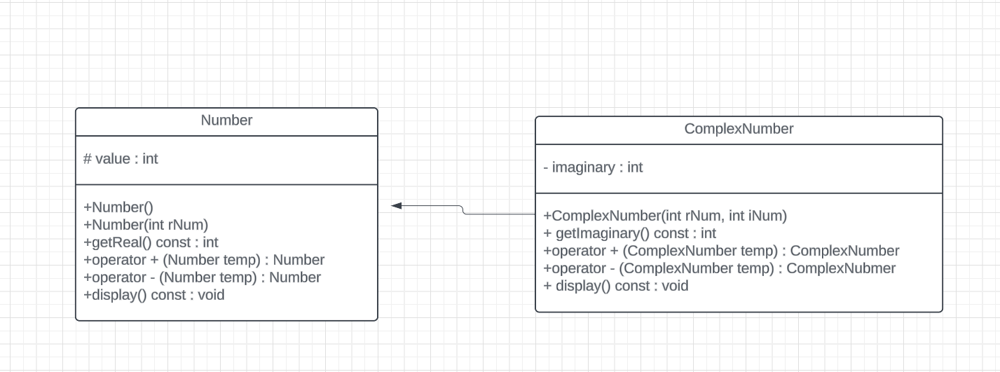

# Testing

|  |  |  |  |  |
| --- | --- | --- | --- | --- |
| Test # | Input value | Expected output | Actual output | Test Pass/Fail |
| 1 | Number num1(5); Number num2(3); | Output: 8  Output: 2 | Output: 8  Output: 2 | Pass |
| 2 | ComplexNumber complex1(4, 2); ComplexNumber complex2(1, 7); | Output: 5 + 9i  Output: 3 – 5i | Output: 5 + 9i  Output: 3 – 5i | Pass |
| 3 | Number num1(0); Number num2(5);  ComplexNumber complex1(3, 0); ComplexNumber complex2(1, 0); | Output: 5  Output: -5  Output: 4 + 0i  Output: 2 + 0i | Output: 5  Output: -5  Output: 4 + 0i  Output: 2 + 0i | Pass |